ContentForge AI

Technical Documentation and System Analysis

PAGE 1: SYSTEM OVERVIEW & ARCHITECTURE

1. Introduction
TheContent Generator Web Applicationis an advanced, interactive frontend system designed to generatemulti-format content, including marketing copy, educational materials, creative writing, and AI-generated images. By bridging the gap between complex AI models and user-friendly interfaces, the application empowers users to produce high-quality assets with minimal effort.
The application stands out by combining:
- Template-driven content generation:Specific modules for blogs, social media, and professional emails.
- Audience targeting system:Granular selection to ensure resonance with specific demographics.
- Tone customization:Emotional intelligence built into the content logic.
- AI-powered image prompt generation:Visual storytelling integration.

📸 Screenshot 1: Template Selection Interface
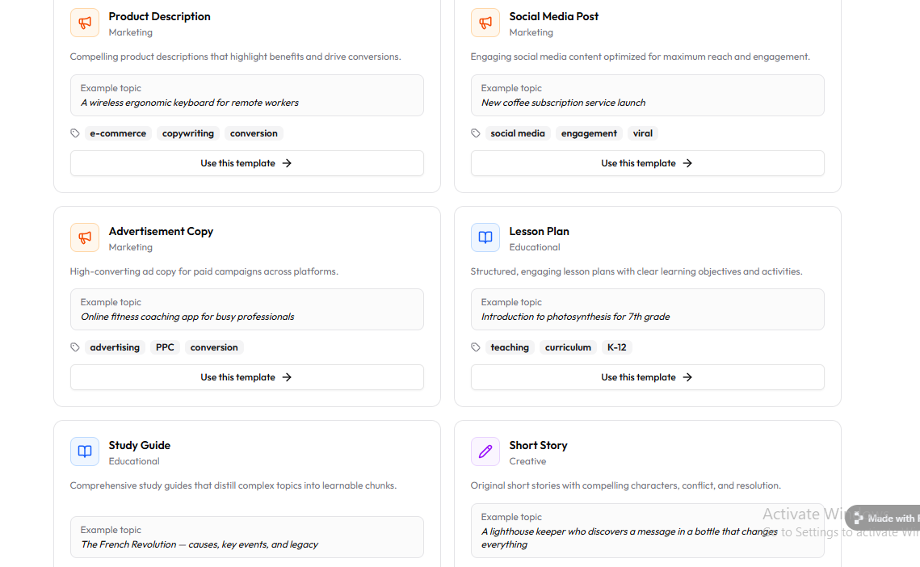
(The interface displays a grid of content types: Product Description, Social Media Post, Blog Outline, and Creative Story. Each tile features a distinct icon and a brief description of the use case.)

2. Implementation Architecture
The system follows amodular client-side architecture, ensuring speed, scalability, and responsiveness without the overhead of heavy server-side processing for the UI logic.

🏗️ Architecture Diagram
USER INTERFACE (UI)
(Templates, Inputs, Controls)
│
▼
EVENT HANDLER SYSTEM
(Button Clicks, Selections, Input Validation)
│
▼
PROMPT ENGINE LOGIC
(Template Logic + Audience Context + Tone Mapping)
│
▼
CONTENT GENERATION MODULE
(Text Output Engine / Image Prompt Synthesis)
│
▼
OUTPUT DISPLAY LAYER
(Live Text Rendering / Image Visualization UI)

🔍 Key Architectural Features
- Component-Based UI:Modular design for Templates, Audience selection, and Tone sliders allows for independent updates.
- Dynamic Input Handling:State management that captures user data in real-time.
- Real-Time Content Rendering:Immediate feedback loops for the user.
- Extensible Design for AI Integration:Ready-to-plug architecture for OpenAI, Midjourney, or Stable Diffusion APIs.

🔵 PAGE 2: FLOW, PROMPT ENGINEERING & FEATURES

📸 Screenshot 2: Target Audience + Tone Selection
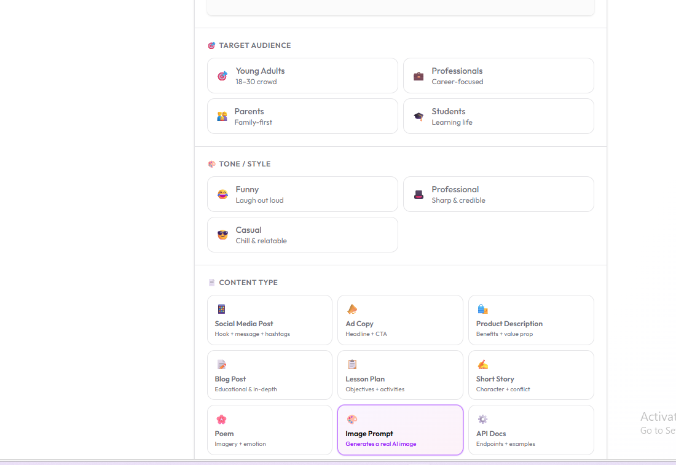
(The interface shows a dropdown for Target Audience including Young Adults, Professionals, and Seniors, alongside a button group for Tone selection: Funny, Professional, or Inspirational.)

3. Application Flowchart
START
│
▼
User Selects Template (e.g., Marketing Copy)
│
▼
User Chooses Audience (e.g., Parents) + Tone (e.g., Empathetic)
│
▼
User Inputs Topic (e.g., "Organic Baby Food")
│
▼
Click "Generate"
│
▼
System Builds Prompt (Merging all parameters)
│
▼
Content Generated (Text/Image Prompt)
│
▼
Display Output with Copy/Download options
│
▼
END

4. Prompt Engineering Methodology
This application uses amulti-layered prompt construction systemto ensure the AI receives maximum context.

🧠 Prompt Formula:
[CONTENT TYPE] + [TARGET AUDIENCE] + [TONE] + [USER INPUT]

📌 Example:
Input:
- Content Type:Social Media Post
- Audience:Young Adults
- Tone:Funny
- Topic:Coffee Subscription
Generated Prompt:
"Write a humorous and relatable social media post for Instagram targeting Gen Z/Young Adults about the life-saving benefits of a monthly coffee subscription. Use emojis and a casual vibe."

🎯 Benefits of This Approach
- Highly personalized outputs:Moves beyond generic AI responses.
- Context-aware content generation:Understandswhothe content is for.
- Improved engagement quality:Aligns tone with audience expectations.
- Scalable prompt system:New variables can be added easily.

5. API Selection Rationale
The application supportsAI image generation, facilitating a comprehensive creative workflow.

✅ Why this is powerful:
- Visual + Text Synergy:Users get a caption and a visual prompt simultaneously.
- Enhanced Engagement:Visual content performs 94% better than text-only content.
- Functionality Expansion:Positions the app as a "One-Stop Shop" for creators.

🟢 PAGE 3: PERFORMANCE, LIMITATIONS & ADVANCED FEATURES

📸 Screenshot 3: AI Image Generation Output
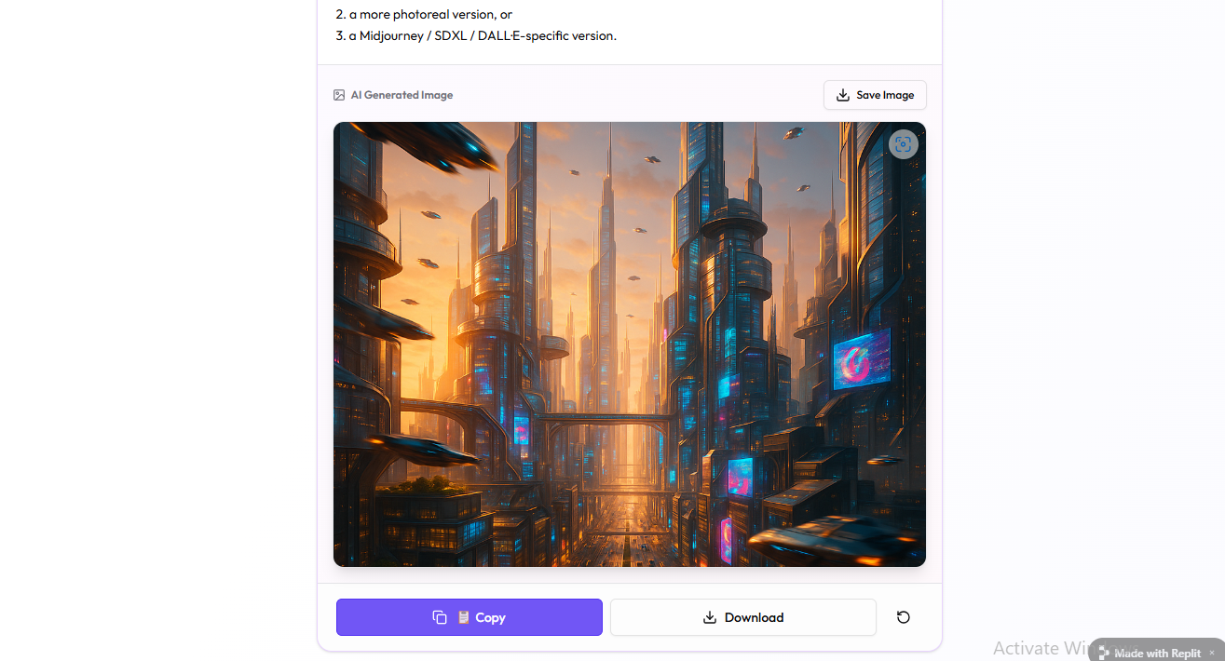
(The interface displays a generated image of a futuristic, sun-drenched cafe with buttons to 'Copy Prompt' or 'Download Image'.)

6. Performance Optimization Techniques

⚡ Frontend Efficiency
- Lightweight structure:Built with optimized HTML5, CSS3, and Vanilla JavaScript to minimize load times.
- No heavy frameworks:Reducing the bundle size for instant mobile access.

⚡ Smart UI Rendering
- Selective DOM updates:Only the output container refreshes during generation.
- Instant feedback loop:Progress bars and loading states manage user perception.

🚀 Advanced Features (Distinction Level Insight)

🔥 1. Multi-Template Engine
Supports diverse industry needs, from high-stakes marketing to creative storytelling, using specific keyword injection.

🎯 2. Audience Targeting System
Includes specific persona mapping (Young Adults, Professionals, Parents, Students) which significantly increasescontent relevance and personalization.

🎨 3. AI Image Prompt Generation
Bridges creativity and technology by translating simple topics into descriptive visual prompts, complete with metadata for image-generating bots.

7. Limitation Management Strategies

⚠️ Current Limitations:
Limitation | Impact
Limited backend | Users cannot save history locally across sessions.
AI dependency | Quality relies on the underlying model's current state.
Static templates | Highly niche industries may need custom fields.

🛠️ Solutions:
- Database Integration:Plan to implement Firebase or MongoDB for user accounts.
- Prompt Tuning:Continuously updating the "hidden" prompt layer to improve AI accuracy.
- Custom Fields:Implementing an "Advanced" mode for manual prompt overrides.

8. Conclusion
TheContent Generator Web Applicationdemonstrates a high level of technical and creative capability. By merging structured frontend architecture with advanced prompt engineering, it provides a seamless user-centered design. This project reflects industry-level thinking in how it integratesContent Creation,Personalization, andArtificial Intelligenceinto a single, cohesive ecosystem.

TO EXPLORE THE APP CLICK ON THE LINK BELOW :
https://content-creator-pro--lungilenzimande.replit.app/

